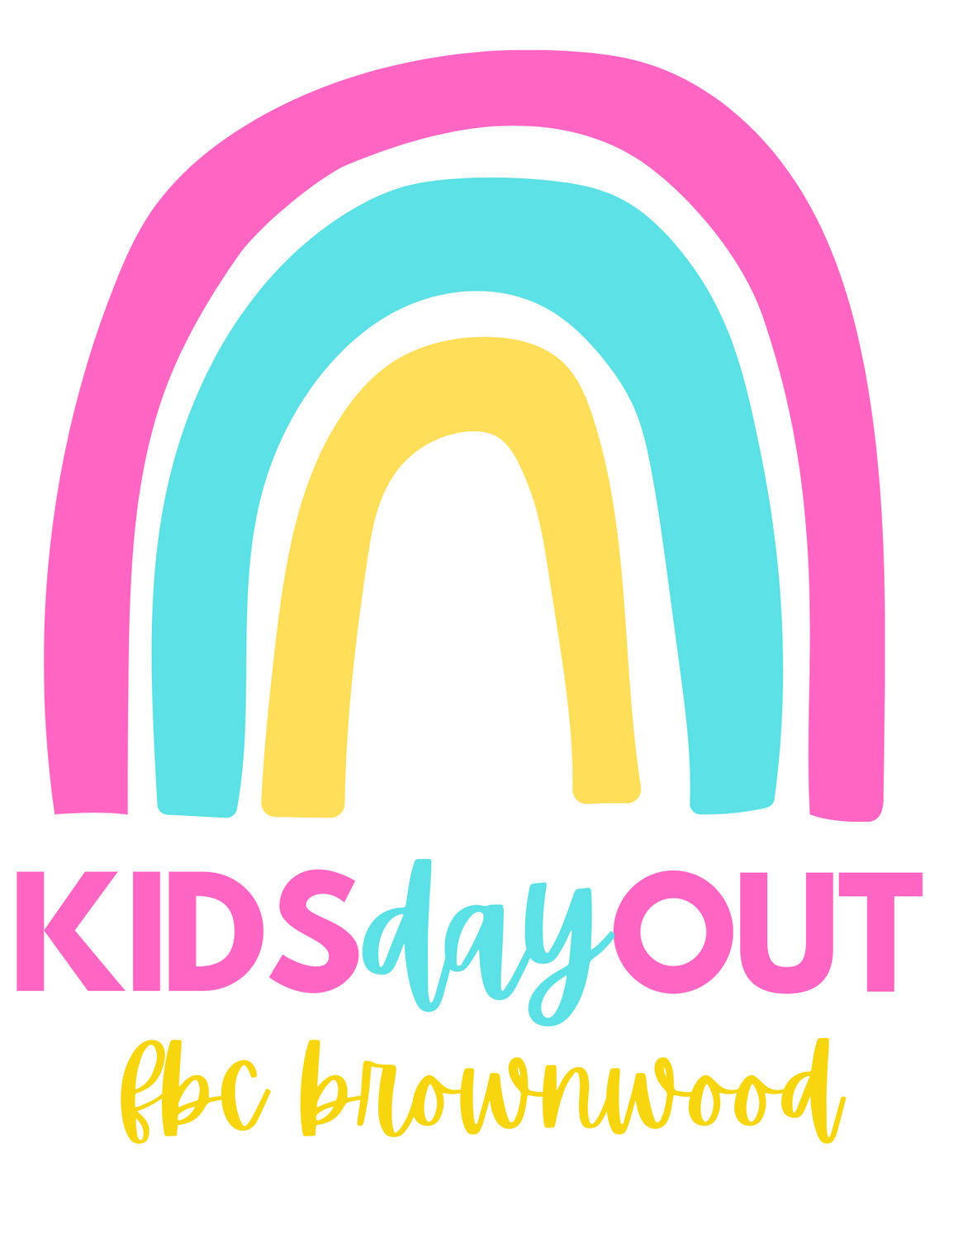

2024-2025 Signature Agreement

The Kids Day Out Program shall provide the following care for:

Name of Child ________________________________________ Date of Birth ______________

Name of Parent _______________________________________ Relationship ______________

Name of Sibling(s) _________________, _______________________, ____________________

For services listed in the Agreement and in accordance with the terms of this Agreement, I agree to pay Kid’s Day Out the monthly sum due on the dates I have been given of:

$125.00 for ________________________ (child’s name) and the registration and materials fees
according to the amounts listed in the Parent Handbook:

Non-refundable $ 35.00 Registration Fee due at time of registration
Non-refundable $ 50.00 Materials Fee due by February 4, 2025.

I agree to cooperate with the general policies of the program, to perform the obligations of parents and/or guardians set forth in the Agreement, and to abide by the rules, regulations, and manuals provided by the program. My signature indicates that I have read the terms of this Agreement and that I have read the rules, regulations, and handbooks provided by the program. It further indicates that I have had this material explained to me and that all of my questions have been satisfactorily answered.

Parent/Guardian ______________________________________ Date _____________________

KDO Director _______________________________________ Date _____________________

______________________________________________________________________________

Parent’s Handbook Agreement

I have read and understand the information included in the Parent’s Handbook. I hereby agree to abide by the policies and procedures stated within.

_________________________________________________ __________________
Mother/Guardian’s Signature Date

________________________________________________ __________________
Father’s/Guardian’s Signature Date

